**Assignment 9**

**Problem Statement:**

You work for a corporation. Their application requires a SQL service that can store data which can be retrieved if required. Implement a suitable RDS engine for the same.

While migrating, you are asked to perform the following tasks:

1. Create a MariaDB Engine based RDS Database.

2. Connect to the DB using the following ways:

a. SQL Client for Windows

b. Linux based EC2 Instance

**Solution:**

Step 1:- Goto the RDS section & select RDS option. In that select MariaDB & select all the options pertaining to free tier & select EC2 option for connection in the configuration window while creating.

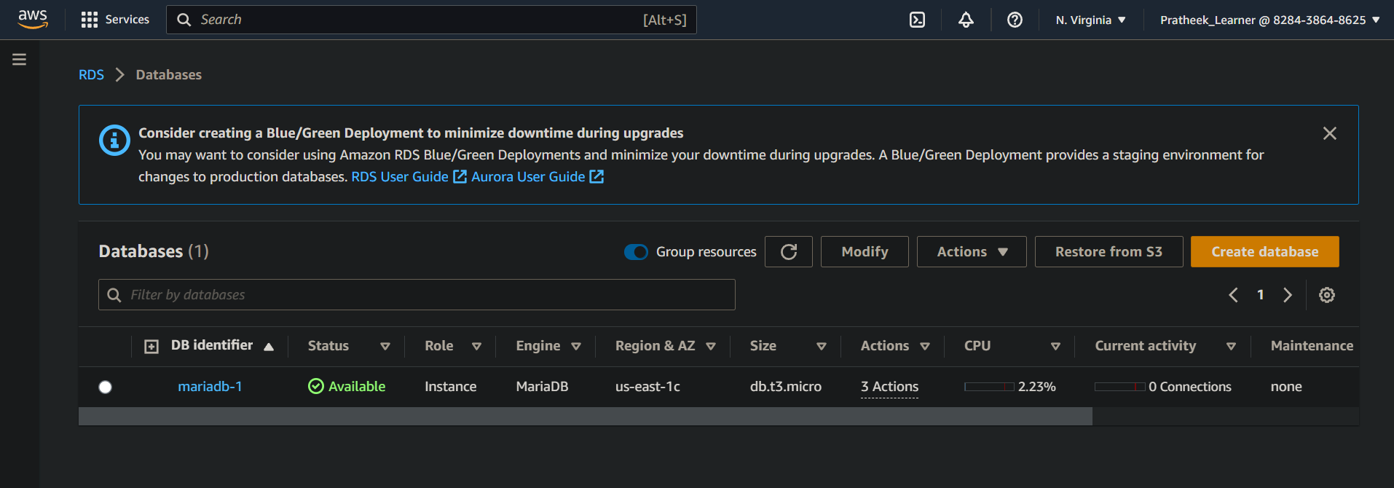

Step 2: - Connect to EC2 instance to which the MariaDB is connected. Then run the following commands:

sudo dnf update -y

sudo dnf install mariadb105 -y

mysql -h endpoint -P 3306 -u admin -p -> Substitute the DB instance endpoint (DNS name) for endpoint, and substitute the master username that you used for admin. Provide the master password that you used when prompted for a password.

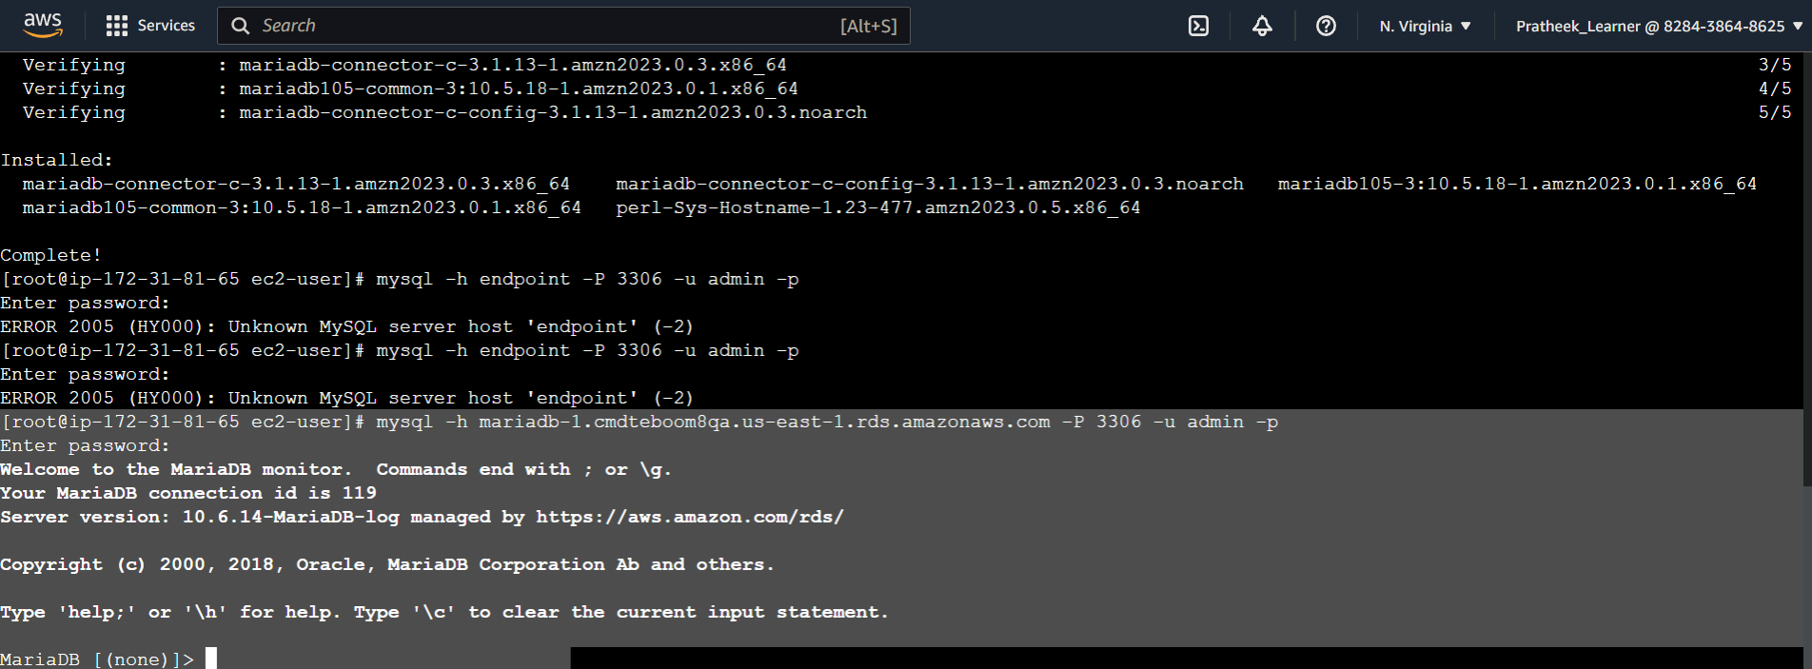

MariaDB to EC2 connection to linux system has been established.

Step 3:- Now to connect aws MariaDB to SQL windows client, download SQL client on wondows OS & then use the MariaDB endpoint to connect the MariaDB.

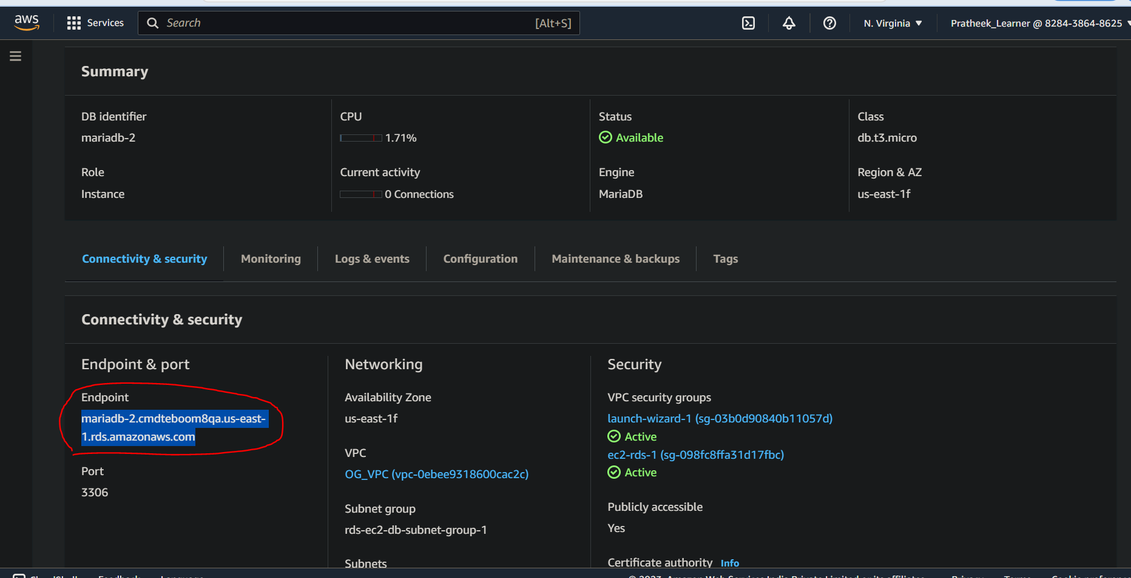

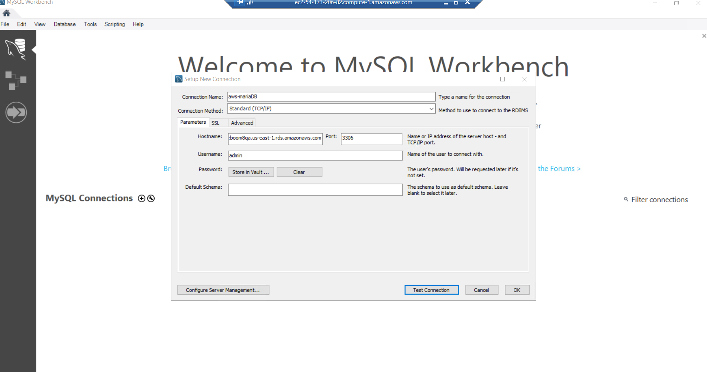

Select test connection, & after it is successful, press ok. So both the connection successful.

